Native Studies 30
Unit 2: Governance

Skill: The Process of Concept Mapping

- Make a list of key concepts (nouns).
- Group the concepts into clusters of closely related ideas.
- Within the clusters, arrange the concepts into a hierarchy under a major concept (categorize).
- Decide how the clusters or categories relate to the organizing concept and/or to each other.
- Arrange the categories into a concept map and circle each concept.
- Connect circles with relationship lines and label each line with a verb or preposition to indicate the relationship between the joined concepts.
- Search for possible cross-relationships on the map.
- If the concept relationships are clearly and correctly labeled, one should be able to read any strand of the map from the organizing concept to the key concept in the cluster to the detailed concepts at the bottom as one would a sentence.
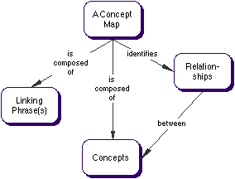
The key attributes of a concept map are:
  - Concepts = nouns (1 non per circle)
  - Hierarchical arrangement
  - Circles linked with relationship lines
  - Lines labeled with verbs, prepositions, or verb phrases
  - Can follow 1 line from top to bottom and have a complete idea

Here is an example of a concept map of terms from American History

http://www.gpc.edu/~shale/humanities/composition/handouts/concept.html)
